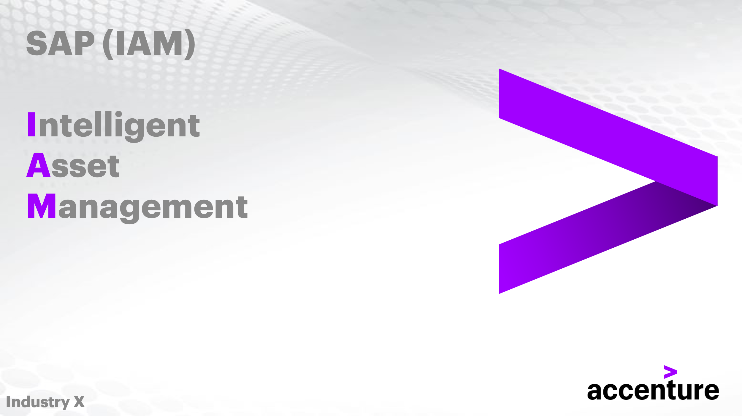

**Conducting a Strategy Assessment for Classes**

Document Control

Prepared by:

|  |  |  |
| --- | --- | --- |
| Version | Date | Name |
| 1.0 | 01/16/2025 | MARIAM FATMA |
| 2.0 |  |  |
|  |  |  |

Reviewed by:

|  |  |  |
| --- | --- | --- |
| Version | Date | Name |
| 1.0 | 01/17/2025 | NIKHIL KOOLWAL, VIJAY PATIL, SRINIVAS RAO PATHI |
|  |  |  |
|  |  |  |

Reference Documents

The following section describes relevant documentation:

|  |  |  |
| --- | --- | --- |
| Document Name | Description | Sharepoint Link |
| Conducting a Strategy Assessment for Classes | Determining the best approach for handling asset failure at the asset class level. | [Conducting a Strategy Assessment for Classes.pdf](https://ts.accenture.com/:b:/r/sites/SAPIAMGlobalInstanceSetUp/Shared%20Documents/General/FY25/DEMO%20SCRIPTS/3.%20Conducting%20a%20Strategy%20Assessment%20for%20Classes.pdf?csf=1&web=1&e=2fDNVR) |
|  |  |  |

Contents

1.Conducting a Strategy Assessment for Classes 4

1.1 Objective 4

1.2 Key Terms, Used in This Lesson: 4

2. Lesson Overview: Strategy Assessments for Classes 6

2.1 Create the Strategy Assessment 6

2.2 Create the Operating Context and Condition(s):  13

2.3 Assign the Catalogs to the Assessment:  16

3. Conclusion 25

3.1 Objective: 25

3.2 Overview: 25

3.3 Outcome: 27

1.Conducting a Strategy Assessment for Classes

* 1. Objective

After completing this lesson, you will be able to conduct a Strategy Assessment for asset classes, considering relevant factors and requirements, to develop strategic asset management plans.

* 1. Key Terms, Used in This Lesson:

**1. Strategy Assessment:** Evaluating the best approach to manage asset failure at the asset class level.

**2. Asset Class:** A group of assets with similar characteristics and managed as a single entity in strategic asset management.

**3. Maintainable Items:** Components or parts of an asset that can undergo maintenance.

**4. Failure Modes:** Specific ways in which an asset or its components might fail.

**5. Failure Mechanisms:** The processes or events that lead to the occurrence of a failure mode.

**6. Causes:** Factors that induce the failure mode.

**7. Failure Effects:** The consequences or outcomes resulting from the failure mode.

**8. Operating Context and Condition:** The conditions under which an asset operates, which could influence its potential for failure.

**9. Failure Data Profile:** A set of predefined failure modes, mechanisms, causes, and effects associated with a particular asset class.

**10. Recommendation:** Suggested actions or strategies to handle potential asset failures.

**11. Catalogs:** Collections of maintainable items, failure modes, mechanisms, causes, and effects used in the Strategy Assessment.

**12. Assessment Status (Created, In Process, Released):** Indicators of the stage of the assessment within the APM system.

**13. Characteristics:** Attributes or properties of assets that affect their performance and risk profile.

**14. Recommendation Type and Subtype:** Categories that define the nature and specificity of the recommendation provided.

**15. EAM (Enterprise Asset Management):** The system from which asset classes and failure data profiles are sourced and integrated into APM for Strategy Assessments.

2. Lesson Overview: Strategy Assessments for Classes

In a Strategy Assessment, we determine what the best approach is for handling asset failure from an asset class level. We will provide in our assessment five main catalogs. Here they are below:

• **Maintainable Items -** The lowest level parts in our asset (pipe in pump).

• **Failure Modes -** Why the item or asset failed (corrosion of pipe).

• **Failure Mechanisms -** Process leading to asset failure (prolonged exposure to water).

• **Causes -** What made the Failure Mode occur (humid work environment).

• **Failure Effects -** Result of Failure Mode occurring (leakage of pipe).

A recommendation can also be added into the assessment. This recommendation will inform the user in the case of this particular asset failure occurring for the specified asset class, this is the best way to handle this situation. These assessments are like FMEA and RCM assessments but are set up on the broader asset class level rather than on the individual asset level that those other assessments focus on.

2.1 Create the Strategy Assessment

On the main page of APM, choose the Strategy Assessments for Classes tile. The tile is in the Assessment Management tab and should be the third tile in the row. If not present, you should also be able to locate the tile by going to the search bar at the top, typing "Strategy Assessment for Classes" in the search field, and then hitting the search button.

On the Strategy Assessment for Classes page, choose the Create button located on the top right of the page underneath the Go and Adapt Filter buttons. Once chosen, you will have a pop up appear on the page with all the necessary fields to fill in for the Assessment.



In here, fill out the Assessment field, the Description field, we will leave the Operating Context and Condition as Yes. This is an additional field we can have for our assessment. When creating the actual assessment itself, we will provide in this field certain characteristics describing details surrounding the operation of the asset that may clarify why it would eventual fail. For example, the Operating Context and Condition may state that a pipe is constructed from iron, which could help better understand why it eventually corroded. With those three fields filled in, choose the box on the right of the Class field to select the asset class being used for the assessment.

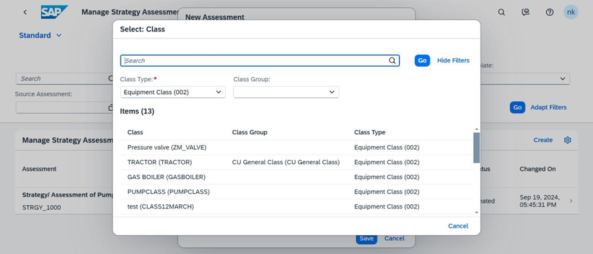

Select one of the provided Classes from the list. Use the search bar or one of the filters to narrow the number of classes to choose from. Make sure to choose the Go button to apply the search bar or the filters.

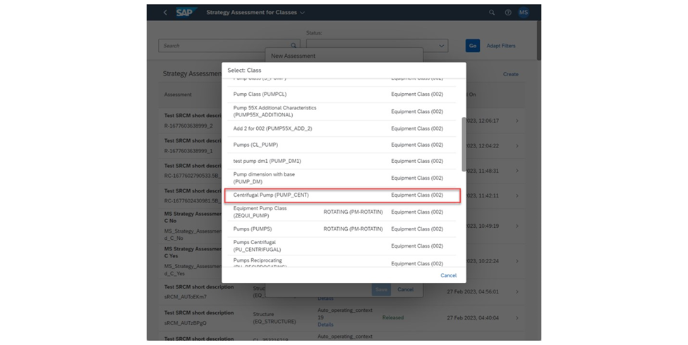

I will be searching for a pump specific class for my asset class that I will use. When I find the one that I would like to use, I will choose on that asset class to use in my assessment.

Once selected, we will do the same for the Failure Data Profile. Choose the box on the right of the Failure Data Profile field to select on for our assessment.



Like before, you can either manually scroll through the list of Failure Data Profiles or you can use the search bar to find a specific Failure Data Profile that you wish to use. Failure Data Profiles, like asset classes, are maintained on the EAM side and pulled over into APM.

Because I chose an asset class related to pumps previously, I will also choose a Failure Data Profile relating to pumps. Select the Failure Data Profile you wish to use by choosing it. Once chosen, it will open and show you its different catalogs

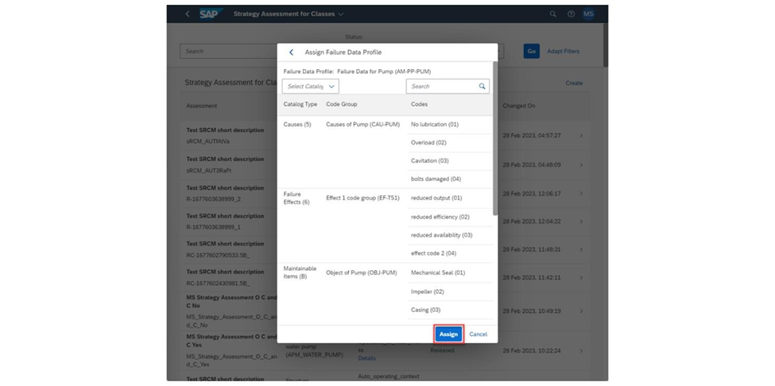

In here, you can view the different catalog types for our assessment. You can also use the search bar and the Select Catalog dropdown to narrow down the number of codes being displayed. The only catalog that is required to be in the assessment is the Failure Modes (D). Although to make the most use out of a Strategy Assessment for Classes, it is best to use a Failure Data Profile that has the five catalogs that were listed in the beginning of this tutorial. If you do not wish to use this Failure Data Profile, choose the back button at the top left of the pop up to choose another one. If this works though, choose the Assign button.

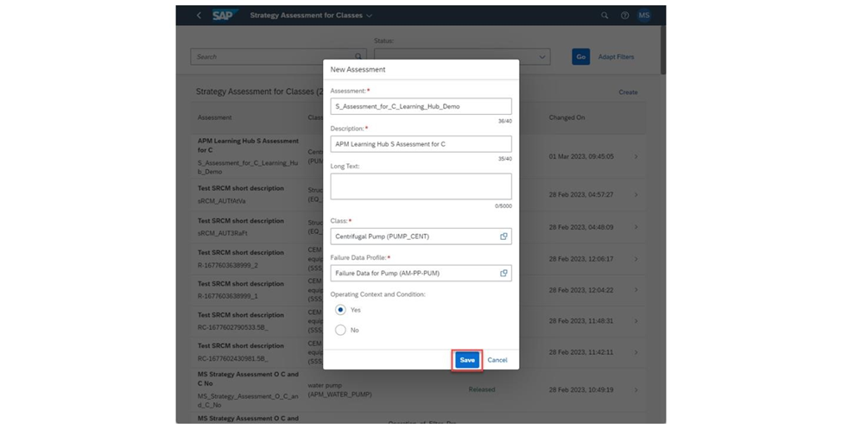

Once all the necessary fields to the Assessment are filled out, choose the Save button to create the actual assessment.

2.2 Create the Operating Context and Condition(s):

When the Assessment opens, you will open to the Information tab displaying general details pertaining to the assessment. The Description and Long Text of the assessment can be changed by choosing the Edit button on the right of the page above the General Information listed. choose the Assessment tab next to the Information tab to add in the information relating to the assessment itself.

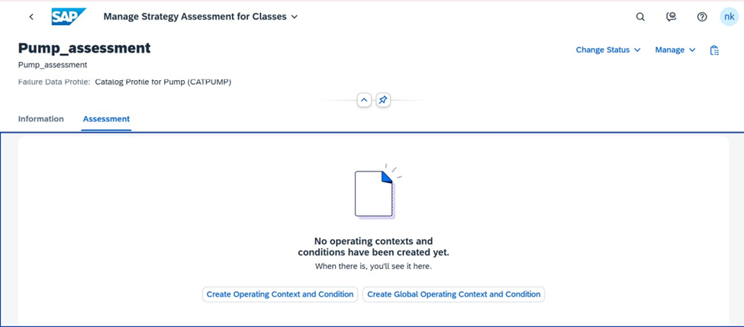

Here, we will create an **Operating Context and Condition** for our assessment. As stated earlier, this will state the surrounding information pertaining to the asset class we are working with and may give some additional information as to the failure of the asset. If when creating the assessment, the *Operating Context* and *Condition* was set to No, then you would instead be asked to assign a Maintainable Item or Failure Mode to the Assessment. Choose the *Create Operating Context and Condition* button in the middle of the page to continue.

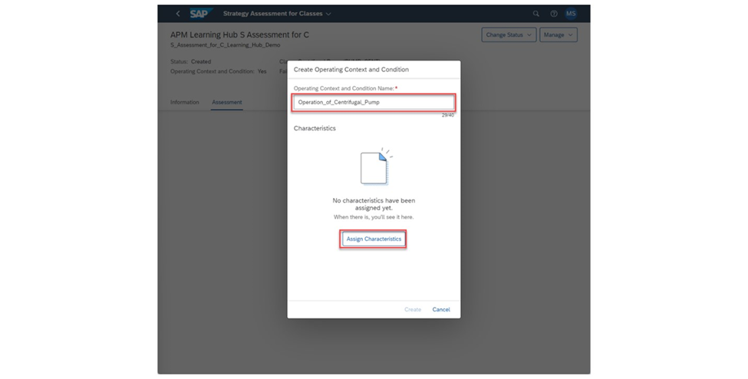

Provide a name for the **Operating Context and Condition** being created. Once finished, choose the Assign Characteristics button to choose the characteristics and their respective values during standard operation

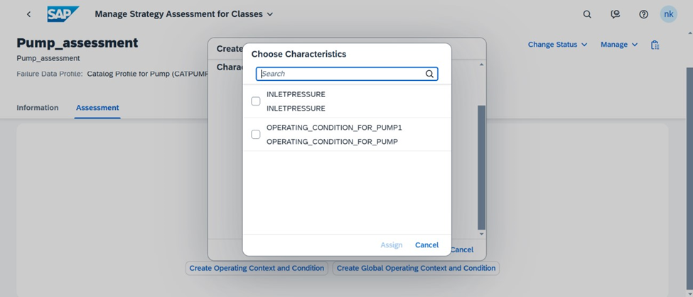

Once the button is chosen, a list of Characteristics will be presented on screen. For my scenario, I only had one Characteristic to choose from. Check the Characteristics you wish to use and choose the Assign button at the bottom of the pop up to select the **Characteristic(s)** being used.

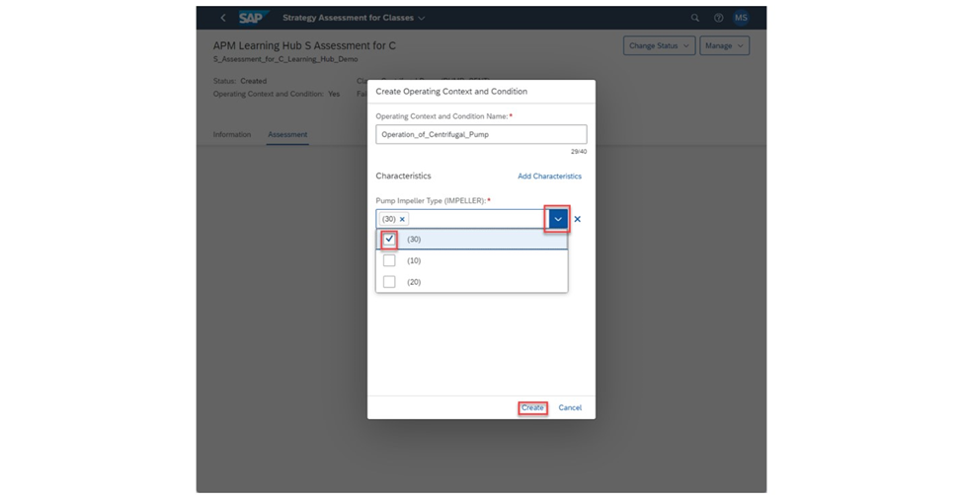

For each Characteristic chosen, select the value(s) in the checklist. Once finished, choose the Create button to create the Operation Context and Condition.

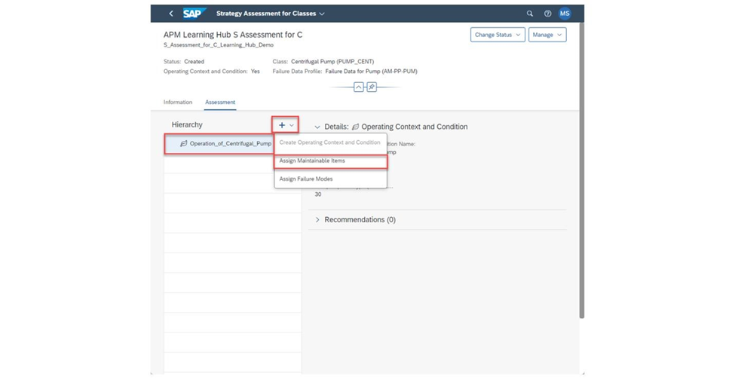

2.3 Assign the Catalogs to the Assessment:

With the Operation Context and Condition created, we can add in Maintainable Items or Failure Modes to them. We can also create additional Operation Context and Conditions as well. To create a new Operating Context and Condition, make sure nothing is selected in the Hierarchy to the left. Then, choose the + button and choose Create Operating Context and Condition.

To assign a Maintainable Item or Failure Mode to the Operating Context and Condition, choose on the Operating Context and Condition in the Hierarchy, choose the + button, and then choose the respective button for the thing you wish to add. I will be assigning Maintainable Items for now

From the list of Maintainable Items here, check which of the ones provided you would like to add to the Operating Context and Condition previously selected. Once finished, choose the Assign button at the bottom of the pop up.

With the Failure Mode(s) added to the Operating Context and Condition, we can now assign the Failure Mode(s) to the Maintainable Item(s). We can also assign Failure Modes directly to the Operating Context and Condition as well. Choose on the item in the hierarchy you wish to assign the Failure Mode to, choose the + button, and then the Assign Failure Modes button.

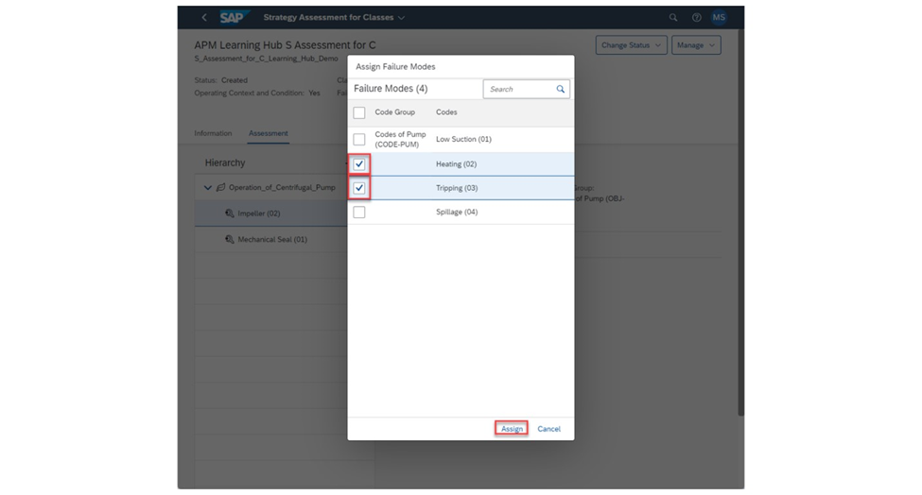

Like before, check which Failure Modes you wish to use for the Assessment and choose on the Assign button once finished.

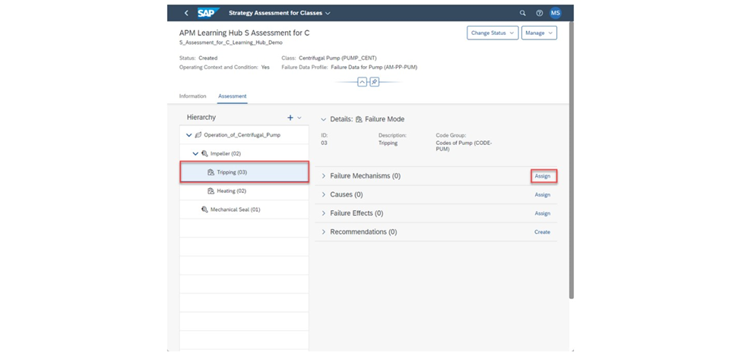

With the failure modes assigned, we can now assign the Failure Mechanisms, Causes, and Failure Effects to our Assessment. We'll first assign the Failure Mechanisms, followed by the Causes, and then finally the Failure Effects.

choose the Failure Mode you wish to assign the Failure Mechanisms to and then choose on the Assign button next to the Failure Mechanisms text.

Check the Failure Mechanisms you wish to assign to your Failure Mode and choose the Assign button once finished.

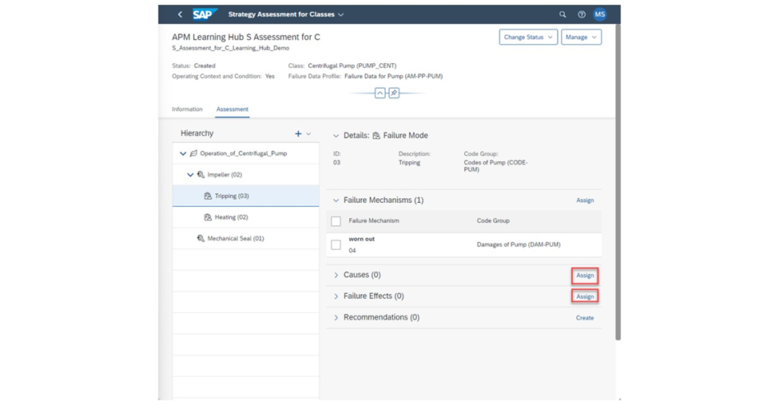

Repeat this process for the Causes and Failure Effects as well.

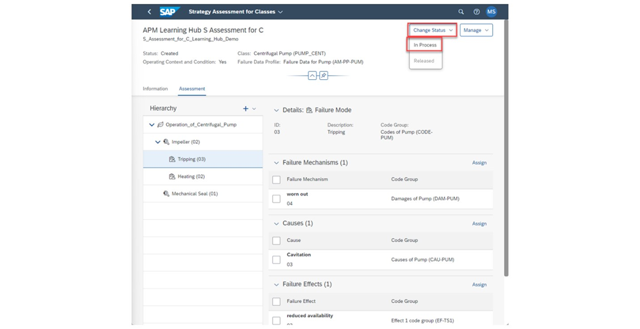

One thing to note is that while working on the Assessment, it is good to denote what the status of the assessment is. Typically, once work on the Assessment has been started but not finished, the Assessment should change its status to In Process rather than the default Created status. At the top right of the page, choose the *Change Status* button and then the In Process sub button. An Assessment cannot be released unless it is in the In Process status. Note that once the status is changed to In Process, you will be unable to delete the Assessment.

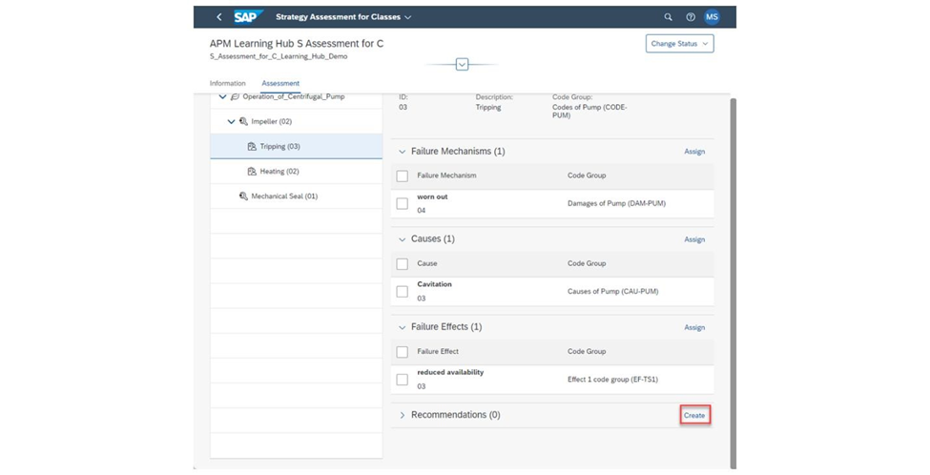

With this completed, we can now create a Recommendation based on the failure catalogs we've provided here. Choose the Create button to the right of the Recommendations text to generate it.

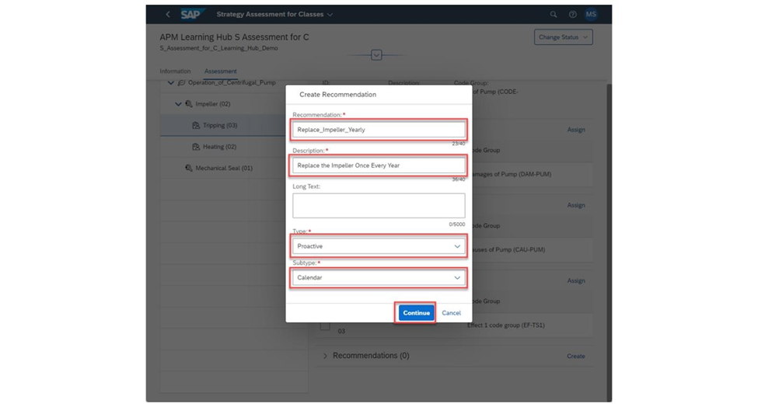

Fill out all required fields in here. These fields are the Recommendation name, the Description, the Type, and Subtype. Note that the Subtype field only appears if the Recommendation Type chosen is Proactive. Otherwise, the field will not show up. Once all fields are filled in, choose the Continue button at the bottom of the pop up.

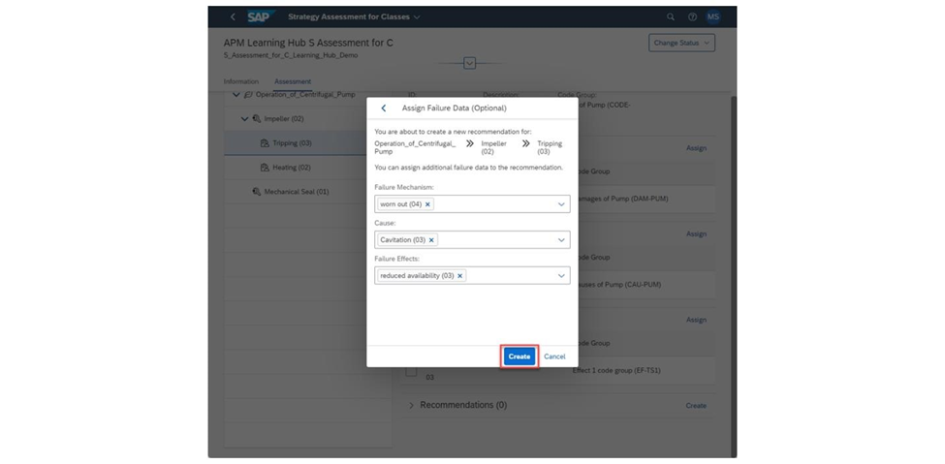

On the next page, you can choose to assign any of the previously chosen Failure Data to the Recommendation. You can assign multiple Failure Mechanisms, Causes, and Failure Effects to the Recommendation or none whatsoever depending on how you determine it. For my demo, I only assigned one of each to my Failure Mode here, so I will use each one for my Recommendation. Once finished, choose the Create button in the pop up to create the recommendation.

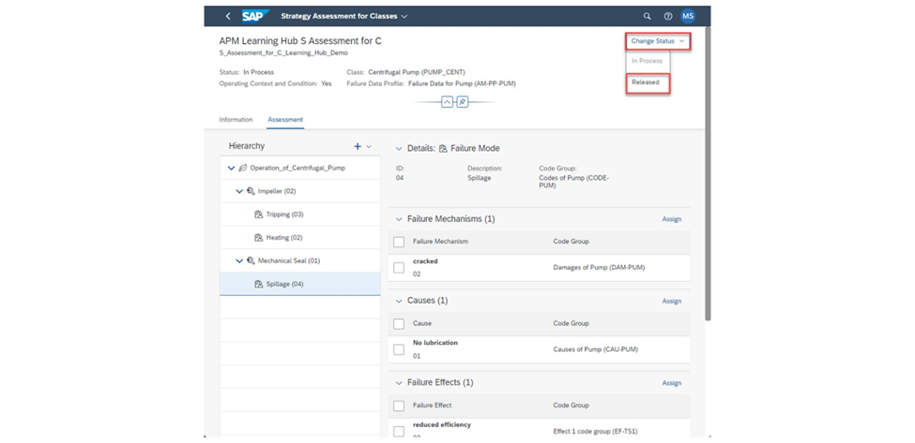

Make sure that all remaining Maintainable Items have at least one Failure Mode assigned to them and that all Failure Modes have at least one Recommendation created underneath them. It is not required to add in a Failure Mechanism, Cause, or Failure Effect for the Failure Modes, however. Once finished, choose the Change Status button, and choose the Released sub button to change the status of the Assessment from In Processed to Released. Note that the status of the Assessment must be in the In Process state for it to change to Released. Change the Status to In Process if not done so already, then change it again to Released.

With the Strategy Assessment Released, we can now use it if we want to evaluate failures within an asset class and determining what may be the best way to resolve a general asset failure here.

3. Conclusion

3.1 Objective:

To learn how to conduct a Strategy Assessment in Asset Performance Management (APM) to determine the best approach for handling asset failure at the asset class level.

3.2 Overview:

A Strategy Assessment considers the broader asset class and provides a structured approach to analyzing failures. It's a step above FMEA (Failure Mode and Effects Analysis) and RCM (Reliability Centered Maintenance), focusing on categories such as Maintainable Items, Failure Modes, Mechanisms, Causes, and Effects. Recommendations are included to guide users in addressing failures.

**Steps:**

1. **Initiating the Strategy Assessment:**

* Navigate to Strategy Assessments for Classes within the Assessment Management tab.
* Use the Create button to initiate a new Strategy Assessment.

1. **Creating the Assessment:**

* Fill out necessary fields including Assessment name, Description, and leave Operating Context and Condition as Yes.
* Select the asset class and the Failure Data Profile appropriate to the assessment's focus.

1. **Building the Operating Context and Condition:**

* Provide details about the operational environment and conditions that could lead to asset failure.
* Include characteristics describing operational details like material composition.

1. **Catalog Selection:**

* Ensure the chosen Failure Data Profile has the five catalogs listed earlier.

* Assign the necessary catalogs to the assessment.

1. **Adding Context and Conditions:**

* Create and name the Operating Context and Conditions.
* Assign characteristics to describe standard operational values.

1. **Assigning Catalogs:**

* Add Maintainable Items or Failure Modes to the Operating Context and Conditions.
* For each Maintainable Item, assign corresponding Failure Modes.
* Sequentially assign Failure Mechanisms, Causes, and Failure Effects.

1. **Assessment Status and Recommendations:**

* Update the assessment's status to In Process when starting work and to Release upon completion.
* Create recommendations for each Failure Mode to provide a proactive resolution path.

1. **Finalizing the Assessment:**

* Confirm all items and modes have associated recommendations.
* Change the status from In Process to Release to complete the assessment.

3.3 Outcome:

The completed Strategy Assessment outlines a comprehensive understanding of failure potential within an asset class, providing a strategic approach to asset failure management. It allows for the identification and resolution of asset failures with a clear, structured methodology at a class level rather than individual assets.